**Subdomains and Use Cases**

-Identify subdomains and classify them in core, supportive or generic

-For each sub domain, identify a set of use cases (lists of actions or steps that define the interaction between a role and a system in order to achieve a goal).

Five main basic subdomains have been identified:

* Subdomain: **User accounts management**: Generic
* Subdomain: **Infrastructure management**: Generic
* Subdomain: **Consumption monitoring management**: Core
* Subdomain: **Aggregate Data monitoring**: Supporting
* Subdomain: **Billing**: Generic

For each subdomain, a set of use cases have been identified.

**User accounts management**

| **User registration**  Main Success Scenario:   1. User download the App from the store (GooglePlay, AppStore) 2. User fills a registration form with basic info (Name, Surname, email, username, pwd, ccard) 3. User submits the registration form 4. System confirms the registration 5. System sends a confirmation e-mail to user 6. Account verified   Extensions:   1. Registration fails: User may re-enter the info |
| --- |

| **User account visualization**  Main Success Scenario:   1. User logins 2. System shows accounts info 3. User logouts |
| --- |

| **User account update**  Main Success Scenario:   1. User logins 2. User updates account info 3. User logouts |
| --- |

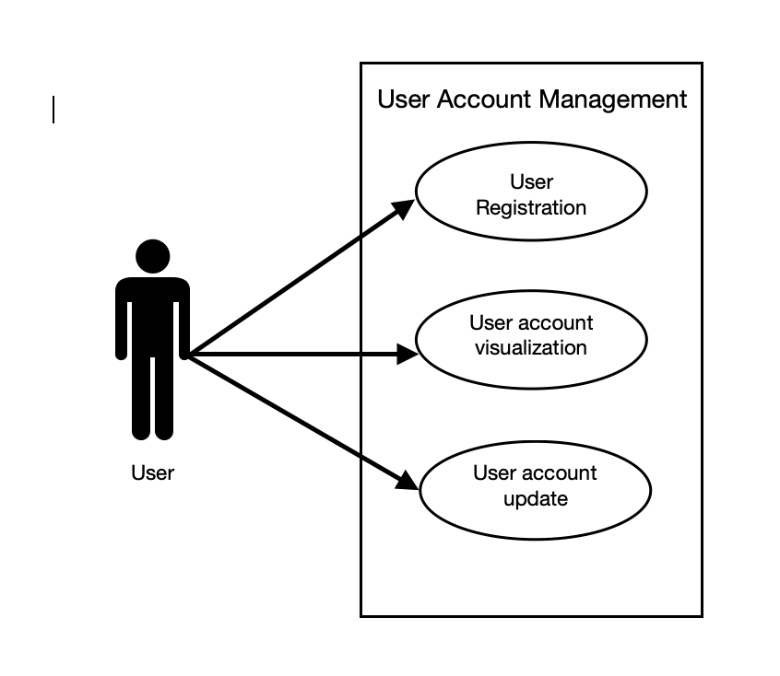

**Infrastructure management**

| **Infrastructure installing**  Main Success Scenario:   1. The company does a site inspection to figure out how many sensors need to be installed. 2. Actual installing of the sensors. 3. Installation of the hub. 4. Testing of the overall functioning. 5. Initialization of the hub. |
| --- |

| **Data collection and gathering**  Main Success Scenario:   1. Collecting data from the sensors. 2. Data gathered by the Hub. 3. Hub algorithms ETL the data. 4. The data is loaded on a server accessible from the app. |
| --- |

| **Infrastructure maintenance**  Main Success Scenario:   1. Sensor signals the need for maintenance. 2. Company identifies Out of Service sensor. 3. Company collects Out of Service sensor. 4. Company performs a check-up of the sensor. 5. Company re-deploy the sensor.. |
| --- |

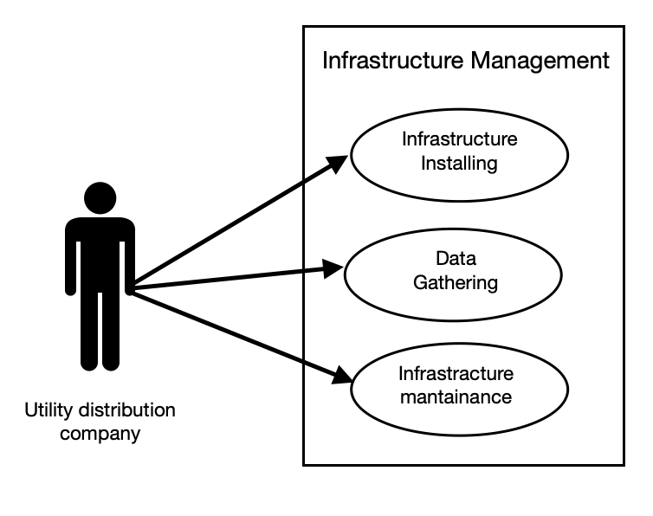

**Consumption monitoring management**

| **Data monitoring/consulting**  Main Success Scenario:   1. User logins. 2. User sees overall consumptions. 3. User sees specific consumptions (i.e. organized for appliances) and relative expenses. 4. User logouts. |
| --- |

| **App updating**  Main Success Scenario:   1. Company analyzes and acknowledges bugs and problems. 2. Try to fix them. 3. Release improved versions of the app. |
| --- |

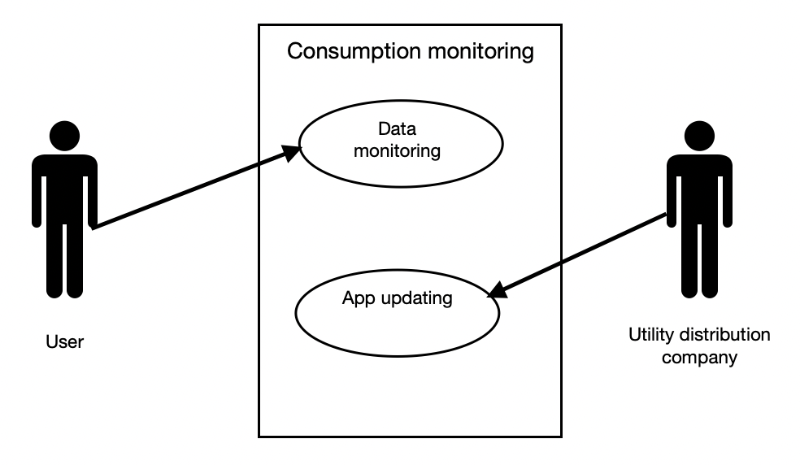

**Aggregate Data monitoring**

| **Data analysis**  Main Success Scenario:   1. Company logins into the company dashboard. 2. System shows aggregate data about users' consumptions (levels and trends). 3. Company selects a user. 4. System shows details about the selected user. 5. Company logs out. |
| --- |

**Billing**

| **Get paid**  Main Success Scenario:   1. Payment service produces billing (each month). 2. User chooses a payment method. 3. User pays service fees. 4. Company collects all the inbounds. |
| --- |